Name = Sheryar Sher

Rollno = 21P-8027

Section = Bs-Cs

Q1:

Code:

# this programs calulate the npr of the given number

def factorial(num):

fact = 1

for i in range(1,num+1):

fact = fact * i

return fact

def npr():

n = int(input("enter the value for n:"))

r = int(input("enter the value for r:"))

N = factorial(n)

R = factorial(n-r)

result = N/R

return result,n,r

npr,n,r = npr()

print("npr for",n,'and',r,"is:",npr)

output:



Q2:

# this program give us the factors of the given number

def factor():

num = int(input("enter number:"))

for i in range(2,num):

if num % i == 0:

print(i,end=" ")

factor()

output:



Q3:

# this program gives us the sum number that are divisible by 3 and 9

def Sum():

num = 1

add = 0

i =0

while i < 10:

if num % 3 == 0 and num % 9 == 0:

add = num + add

i+=1

num+=1

else:

num+=1

return add

add = Sum()

print("the sum of first 10 num which are divisible by 3 and 9 is:",add)

output:



Q4:

# this program calculate us the fibonachi numbers

def fibonachi(num):

a = 0

b = 1

for i in range(num):

print(a)

add = a + b

a = b

b = add

num = int(input("enter number till which you want to calculate: "))

fibonachi(num)

output:

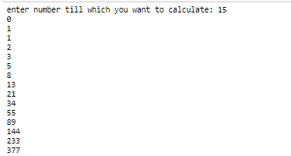

Q5:

Code1:

def vote(bev):

coff =0

tea =0

orange =0

juice = 0

if bev == 1:

coff +=1

elif bev == 2:

tea+=1

elif bev == 3:

orange+= 1

elif bev == 4:

juice+= 1

return coff, tea, orange, juice

def favBev():

Coff = 0

Tea = 0

Orange = 0

Juice = 0

counter = 1

print("Choose your favourite beverage from the following list")

print("1.Coffee 2.Tea 3.Orange 4.Juice")

beverage = 0

while beverage != -1:

coff, tea, orange, juice = vote(beverage)

Coff+=coff

Tea+=tea

Orange+=orange

Juice+=juice

beverage = int(input("Please input the favourite beverage of person#{}. Choose 1,2,3,4 from the above menu or -1 to exit the program:".format(counter)))

counter+=1

return Coff, Tea ,Orange , Juice

coff, tea ,orange , juice = favBev()

print("""Beverage Name of votes

***********************************""")

print('1.Coffee'," ",coff)

print('2.Tea'," ",tea)

print('3.Orange'," ",orange)

print('4.Juice'," ",juice)

code2:

def favBev():

Coff = 0

Tea = 0

Orange = 0

Juice = 0

counter = 1

print("Choose your favourite beverage from the following list")

print("1.Coffee 2.Tea 3.Orange 4.Juice")

beverage = 0

while beverage != -1:

if beverage == 1:

Coff+=1

elif beverage ==2:

Tea+=1

elif beverage == 3:

Orange += 1

elif beverage == 4:

Juice +=1

beverage = int(input("Please input the favourite beverage of person#{}. Choose 1,2,3,4 from the above menu or -1 to exit the program:".format(counter)))

counter+=1

return Coff, Tea ,Orange , Juice

coff, tea ,orange , juice = favBev()

print("""Beverage Name of votes

***********************************""")

print('1.Coffee'," ",coff)

print('2.Tea'," ",tea)

print('3.Orange'," ",orange)

print('4.Juice'," ",juice)

output:

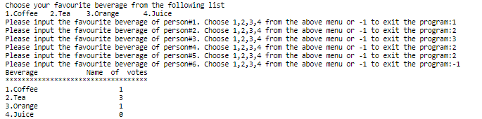

EXTRA TASK

num1 = int(input('enter number'))

num2 = int(input('enter number'))

num = 1

mod = 1

if num>num2:

Max = num1

else:

Max = num2

if num>num2:

Min = num2

else:

Min = num1

while num <= Max:

if num < Max and num > Min:

if num == mod:

print(num)

num+=1

mod = 2

elif num % mod == 0:

num+=1

mod=2

else:

mod+=1

else:

num+=1

output:

